### **Name:** Hafiz Muhammad Ammar Qasim

### **Registration #:** SP24-BSE-029

### **Section:** BSE-B

Documentation: Student Enrollment System

This is a JavaFX-based GUI application for a **Student Enrollment System**, allowing users to register students with details such as name, father's name, CNIC, date of birth, gender, city, and an optional profile image.

## Core Features

1. **Start Screen:**
   * Displays a welcome message.
   * Button to navigate to the registration form.

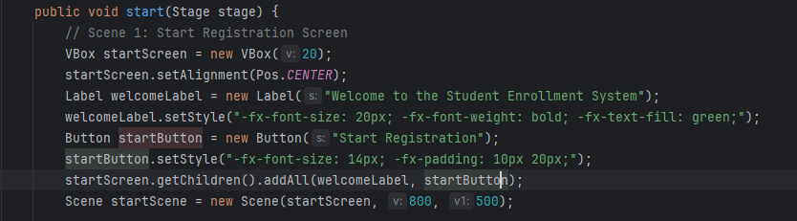

**Registration Form:**

* Fields for entering:
  + **Name**
  + **Father's Name**
  + **CNIC**
  + **Date of Birth**
  + **Gender** (Male/Female/Other)
  + **City**

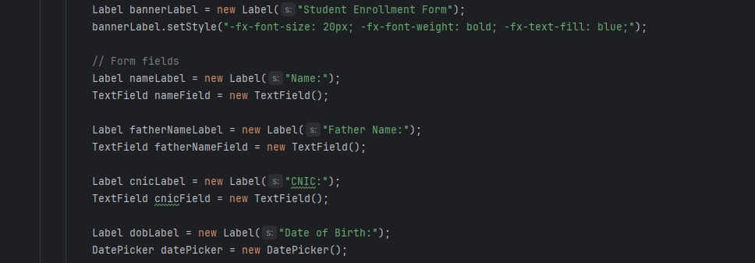

**Image Selection:**

* Allows users to upload a profile picture.
* Image is displayed in a bordered viewer once selected.

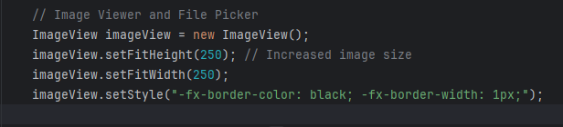

**Save Functionality:**

* Collects data entered by the user.
* Creates a Person object with the input data.
* Prints the saved data to the console.

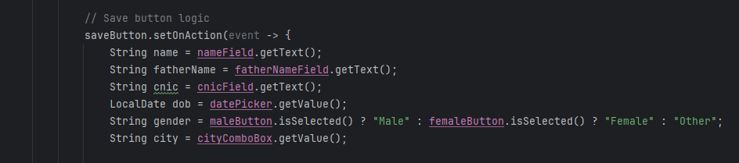

**Student Class (Person):**

Represents the student data model with the following fields:

* **name, fatherName, cnic, dob, gender**, **city**, and **image**.
* Provides getter methods for data retrieval.

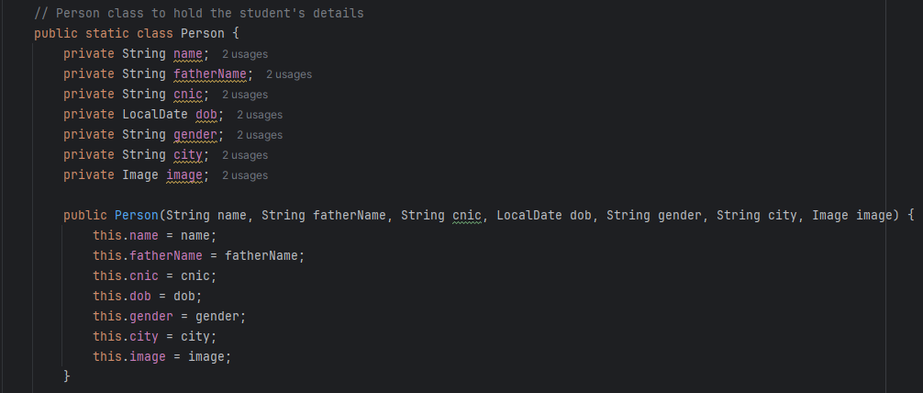

**Switching Scenes:**

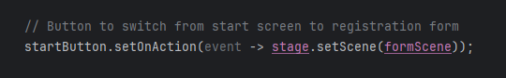

## Output Documentation

#### **1. Start Screen**

* + **Description:**This screen welcomes the user and provides a button to start the registration process.  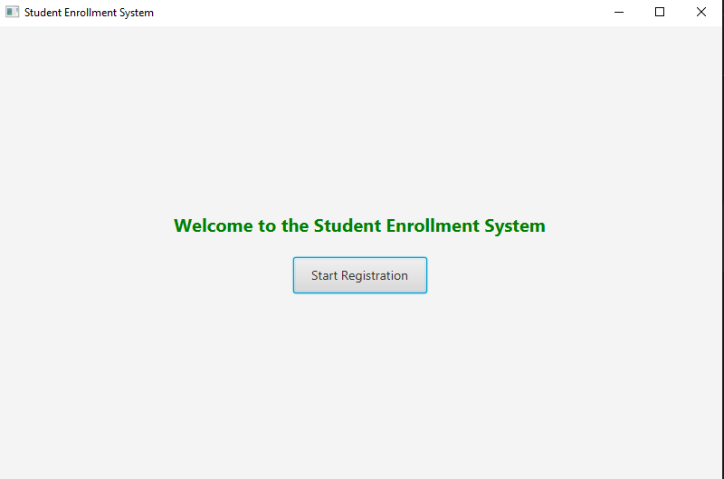

#### **2. Registration Form**

* **Description:**A detailed form where users can enter student details like name, father's name, CNIC, date of birth, gender, and city, and upload a profile image.
* **Screenshot:  
  *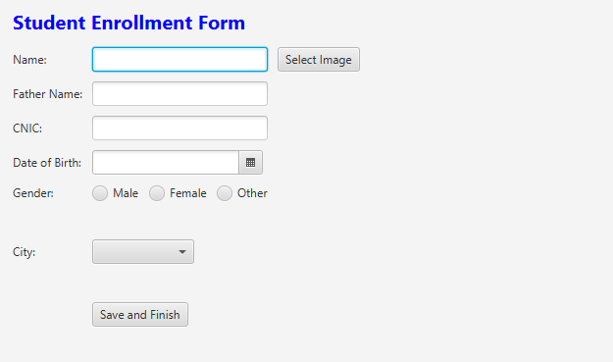***

#### **3. Data Upload**

* **Description:**Shows the selected data displayed in the viewer.
* **Screenshot:**

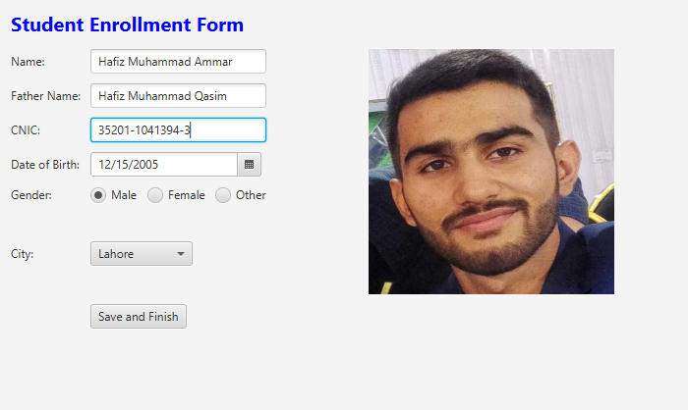

#### **5. Console Output:**

* **Description:**The saved student details displayed in the console after clicking the Save button.
* **Screenshot:**

